Figure 1. Model Presentation

Figure 2: Faculty members with Guest Dr. Nidhi Shah

Figure 3: Students of Operation theatre & Anaesthesia Technology with Faculty members

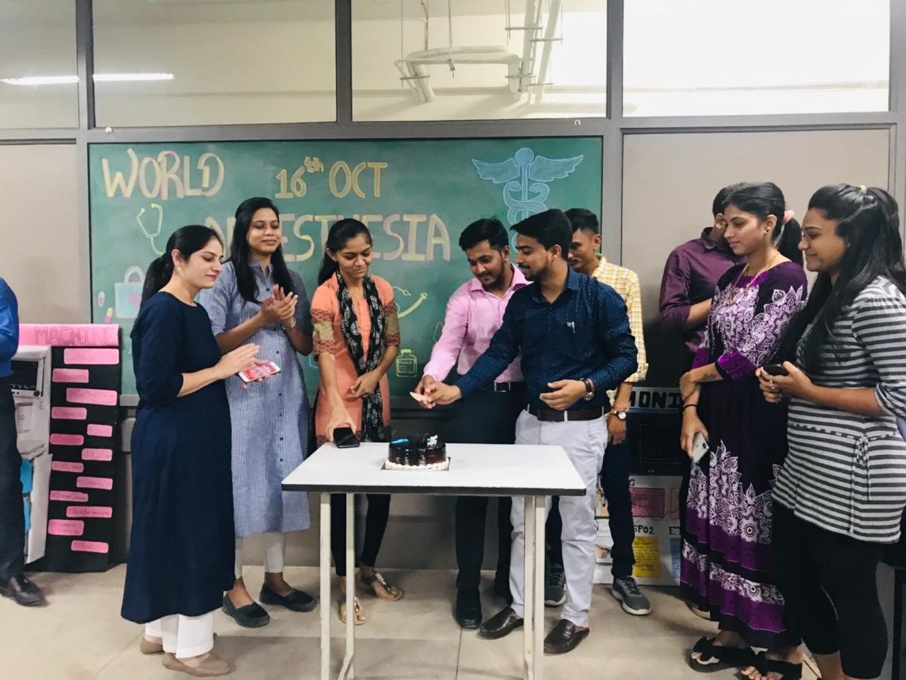

Figure 4: Cake cutting ceremony